Capital Improvement Sales Tax Fund – Capital Improvement Projects
Project Name:  Maple Lane Sidewalks | Department:  Public Works
Type of Project:  New Infrastructure | Contact:  Chuck Soules
Total Project Cost:
$700,000

Description:
The Maple Lane Sidewalks project focusses on enhancing pedestrian safety and accessibility. It will establish a safe route to Maple Elementary School and connect neighborhoods with existing sidewalks. The project will construct 1500 feet of 5-foot-wide sidewalk on Maple Lane from Pine Street to Maple Avenue. A Pedestrian crossing with flashing beacons will be installed for safe crossing to the school on Maple Avenue.
Justification:
This project will connect existing sidewalks along Maple avenue and Pine Street. As identified in the City's Transportation Master Plan, several short sidewalk connections are needed throughout Smithville to connect between neighborhoods and other destinations. Residents have multimodal options within their own neighborhood, but do not have the infrastructure to safely travel to other destinations. The need for more sidewalks and multi-use paths emerged as a major theme in the Transportation Master Plan.
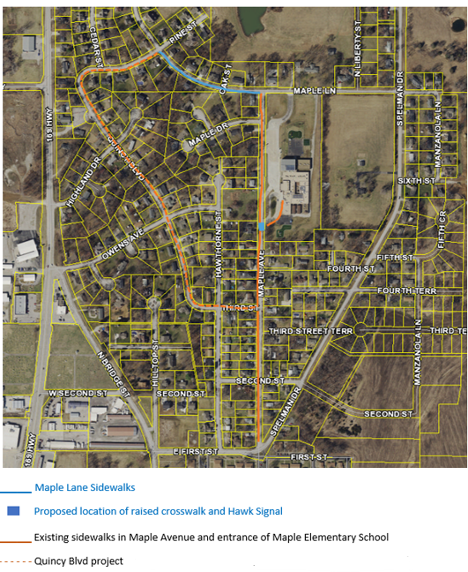

Planned Expenditures
 | FY2026 | FY2027 | Total
Engineering | $100,000 | - | $100,000
Construction | - | $600,000 | $600,000
Total | $100,000 | $600,000 | $700,000

Funding Sources
 | FY2026 | FY2027 | Total
Capital Improvement Sales Tax | $100,000 | $600,000 | $700,000
MARC Grant  Reimbursement | - | ($480,000) | ($480,000)
Total | $100,000 | $120,000 | $220,000

